**SWM – Workflow of converting a non-member/ Former member to active member**

**Step 1:** When a non-member/ former member tries to become an active member, they will click on “Join WEB” button in website. It will go to add member form where, when email ID (of non-member/former member in system) is entered a message will display saying “You are not an active member of WEB, click here to activate your account”.

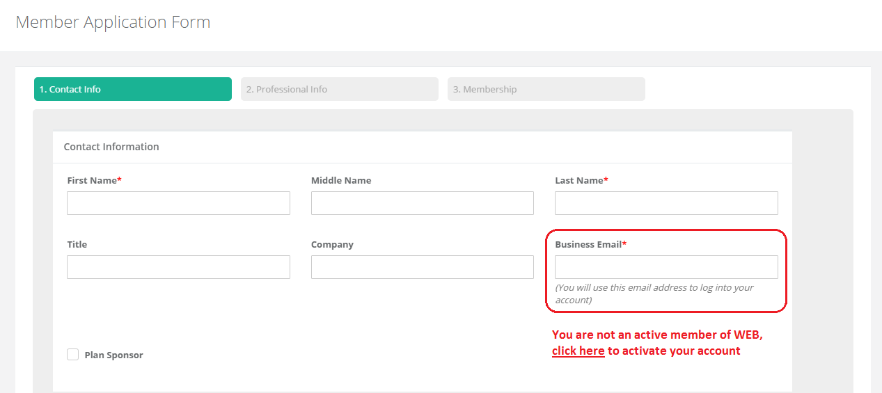

**Step 2:** When user clicks on the link, a pop up will appear with a message saying, “A verification mail has been sent to your mail ID, please check your mail to continue”.

**Step 3:** Verification mail will have a link, when clicked upon it will take the user to a page where they can choose a membership type of their choice and join WEB.

